DMS migration documentation and steps
Documented by : gourav.binodkumardas@dxc.com
Date: 1st April 2026

The document include steps required for side-by-side upgrade of Cloud SQL server 2019 to Cloud SQL sever 2022

- Create a new Cloud SQL instance with same configurations , and most important in the same region as the source 2019 instance .
- Don’t enable PITR during creation of new 2022 instance , if enabled make sure to disable it .
- Create a gcs bucket strictly with below mentioned structure :
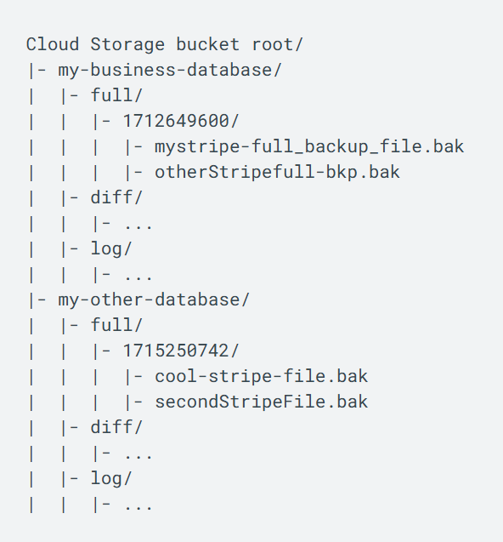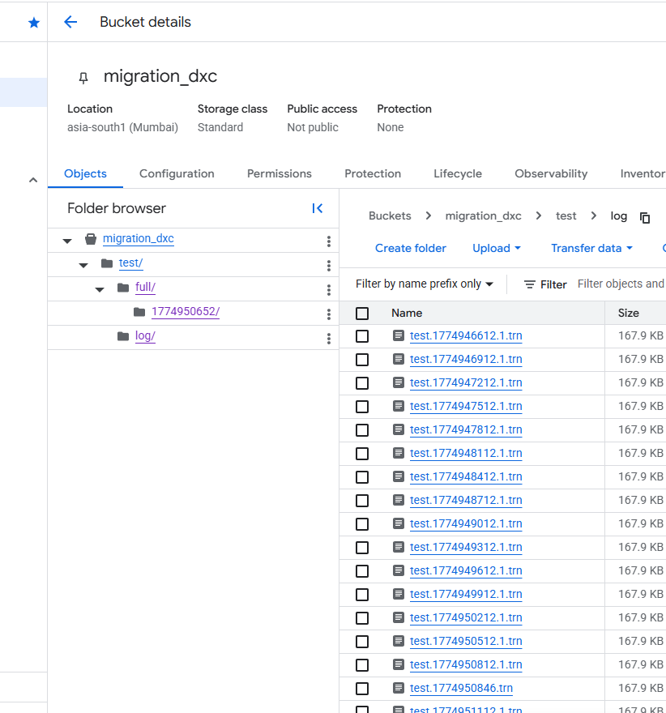

Ephoc unix time stamped folder is very important for DMS and it must be created within the guidelines strictly : refer below documentation for better info on DMS guidelines .
https://docs.cloud.google.com/database-migration/docs/sqlserver/export-backup-files

Refer below documents on exporting the different backups from GCP console as Cloud SQL is a managed instance , and we don’t have much access to the infra behind , like storage and other resources .
https://docs.cloud.google.com/sql/docs/sqlserver/import-export/import-export-bak

- Once GCS bucket is created , please grant Storage Admin /Storage Object Admin role to the service account of both Source and Destination instances .
PFB reference :
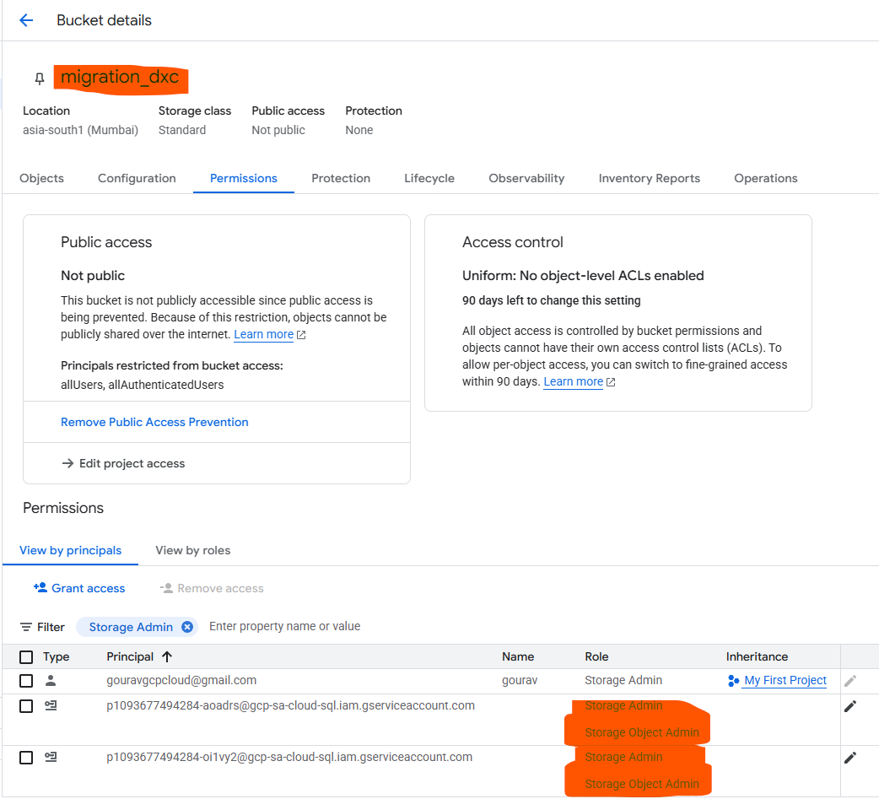

- Once both service accounts of Source and destination has the access lets proceed taking backups .

- Command to get epoch unix time stamp , Run in cloud shell ,
date +%s
- Now lets take a full backup first using gcloud for one database on our source instance:

gcloud sql export bak prod2019 \
gs://migration_dxc/test/full/1774950652/test.bak \
--database=test

prod2019 is instance name , gs:\\ is our gcs bucket path and test is the database name .
- As soon as backup is finished run the below command to get the timestamp when the full backup export was successful , we would need that tie stamp to get all the tlogs until cutover .
gcloud sql operations list --instance=prod2019 --limit=10

- The first few lines will show an END time that’s our time to initiate the log backups when required .
gouravgcpcloud@cloudshell:~ (project-7e6ee409-ba67-46a1-a84)$ gcloud sql operations list --instance=prod2019 --limit=10
NAME: 361f7bdc-2552-454e-8b6d-d71b0000002f
TYPE: EXPORT
START: 2026-03-31T15:18:10.307+00:00
END: 2026-03-31T15:18:52.177+00:00
ERROR: -
STATUS: DONE

- Lets take the log backup now , our first log backup after the full backup , using below command ,

gcloud sql export bak INSTANCE_NAME gs://BUCKET_NAME/FOLDER_PATH
--export-log-start-time=START_DATE_AND_TIME /- this should be the full backup end time
--export-log-end-time=END_DATE_AND_TIME /
--database=DATABASE_NAME --bak-type=TLOG

Eg.

gcloud sql export bak prod2019 gs://migration_dxc/test/log/test.1774970269.trn \
--export-log-start-time=": 2026-03-31T15:18:52.177Z" \
--export-log-end-time=": 2026-03-31T17:18:52.177Z" \
--database=test --bak-type=TLOG

IMPORTANT : instead of start and end time if we only give the end time then also it will load all the log backups from the moment full backups happened last till the end time we gave , so all log files will be exported .

- Once this is done few points to remember very important :
- Folder structure is very important and strictly to be followed .
- The log backup file should be of this name databasename.epochunixtime.trn
Strictly and it must be under the log folder .

- Now we have our backups ready , but there is a small issue ,
The full backup is fine in the bucket it has been exported , but log backups have issues , the structure is incorrect and the log files which are exported in .log format with a different naming standard ,which is not recognized as per the DMS guidelines .

- To fix this I have created a script to rename the log files backup from .log to .trn and the move it to the desired location as per DMS standard.

# 1. DOUBLE CHECK YOUR BUCKET NAME HERE
BUCKET_NAME="migration_dxc"
BASE_PATH="gs://${BUCKET_NAME}/test/log"
DB_NAME="test"

# 2. Run the recursive loop
# We use the full gs:// path to prevent the "file://" error
for file_uri in $(gcloud storage ls "${BASE_PATH}/**.log"); do
filename=$(basename "$file_uri")

# Extract the timestamp: 2026-03-31-08-43-32
ts_raw=$(echo "$filename" | grep -oE '[0-9]{4}-[0-9]{2}-[0-9]{2}-[0-9]{2}-[0-9]{2}-[0-9]{2}')

# Extract the stripe/part number (the _1_ or _2_ in the filename)
part_num=$(echo "$filename" | grep -oE '_[0-9]+_dba' | cut -d'_' -f2)

if [ ! -z "$ts_raw" ]; then
# Format for the date command: YYYY-MM-DD HH:MM:SS
formatted_ts=$(echo "$ts_raw" | sed 's/-\([0-9]\{2\}\)-\([0-9]\{2\}\)-\([0-9]\{2\}\)$/ \1:\2:\3/')

# Convert to Unix Epoch (UTC)
epoch=$(date -u -d "$formatted_ts" +%s)

# Construct the new DMS name
new_name="${DB_NAME}.${epoch}.${part_num}.trn"

echo "Processing: $filename -> $new_name"

# Move the file out of the subfolders to the main /log/ folder
gcloud storage mv "$file_uri" "${BASE_PATH}/${new_name}"
else
echo "Could not parse date from $filename"
fi
done
This script runs in loop and fixes all the transaction log files which exported to the bucket with different name and wrong paths .
- Once this is all done, we can remove the extra empty folders , note not to delete the log and full folder which contain actual backups .
- Now we are halfway through the DMS process ,
Let’s focus on the next part Creating DMS job (continuous)
- Search of Database Migration and open it , if not enabled , then enabled Database migration API .
- Create Migration Job , and choose source and destinations as below :
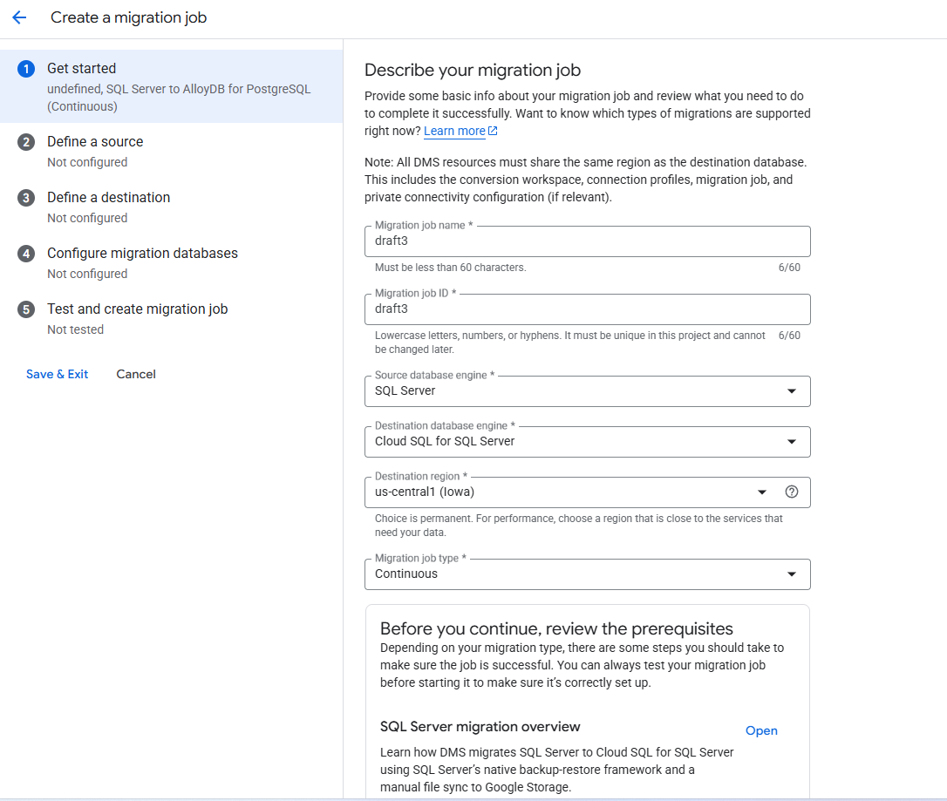
- Cloud SQL does not allow migrating from CLOUDSQLMSSQLserver to CLOUDSQLMSSQLServer, so we chose source as SQL server and destination as per the mentioned screenshot .
- Once Job created make sure you create connection profiles source and destination , and better give credentials of user -sqlserver , as that has the highest access on the instance for us .
- Once created follow the steps as per instructions on that page and ensure that migration job is created and then start it .
Once test it and start, if all the things are as per guidelines such as backup size of each file, location of the backup files in correct order and credentials of connection profile.
It should succeed .
- After successful completion you would see logs of the job as below :
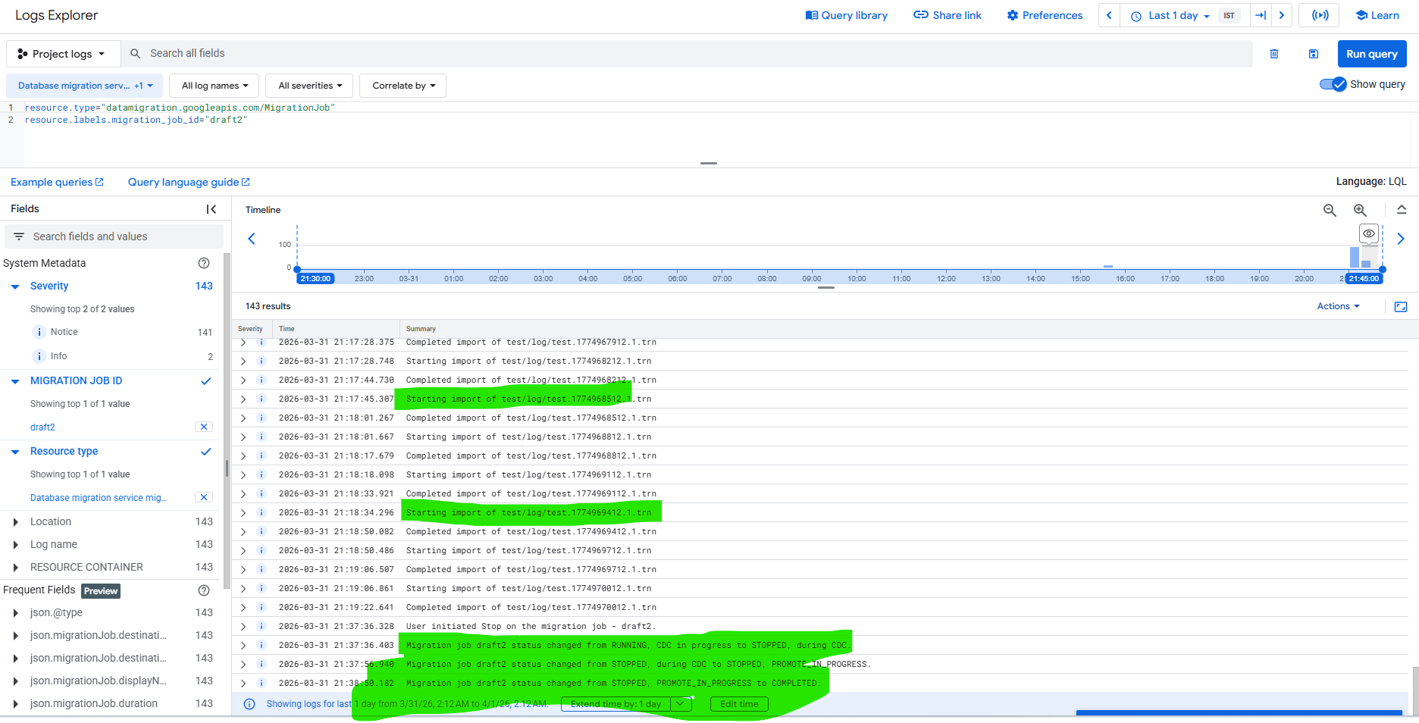

Once this is done and the logs are successfully restored then we get and option to Promote , once we click promote the destination SQL instance becomes active and accessible .

NOTE: THIS ONLY MIGRATES USER DATABASES INDIVIDUALLY and not other instance objects such as logins and SQL Agent jobs are created it has to be copied and created manually to the new instance .

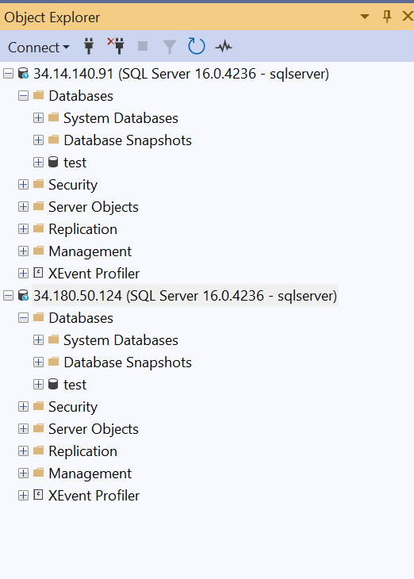

migration_dxc/test/log/test.1774950846.trn/test/logs/e4bf074d-9486-4e4e-ba99-07eb3079aa50_1_dba/*.log

